Research Title
Name SURNAME^{1*}, Name SURNAME², Name SURNAME³
¹Affiliation, Address, Country
^{2,3}Affiliation, Address, Country
*Corresponding author. Email address:
Abstract – Both the full-length peer-reviewed papers and a collection of abstracts (Book of Abstracts) will be published in the journal Environmental and Climate Technologies after the conference. Book of Abstracts contains only abstracts or extended abstracts of the presented papers. An abstract is a short, yet complete and comprehensive statement about your research paper. The abstract should contain 250–400 words in length (in MS Word highlight the section, Review/Word Count). Give a concise summary of the paper: research focus, research methods used, results and the main conclusions and recommendations. Ensure that your abstract reads well and is grammatically correct. Start with giving a brief and precise description of the problem or issue. Follow by an outline of the research methods, design and algorithm used in your study. Finally, describe the major findings and the conclusions reached. The abstract should end with one or two sentences that describe results achieved in the course of the study. Please use Word, font style Times New Roman, font size 9. A graph, a figure or other visual means added at the end of the abstract will help to make the abstract more attractive and will illuminate your main findings. The abstract should fit into one page.
Keywords – Choose about 4 to 9 keywords. The keywords should not overlap with the words in the title. Capitalize the first word of the keywords list. Include the definition of an acronym followed by the acronym in parentheses. Separate keywords with semicolons and organize them in alphabetic order
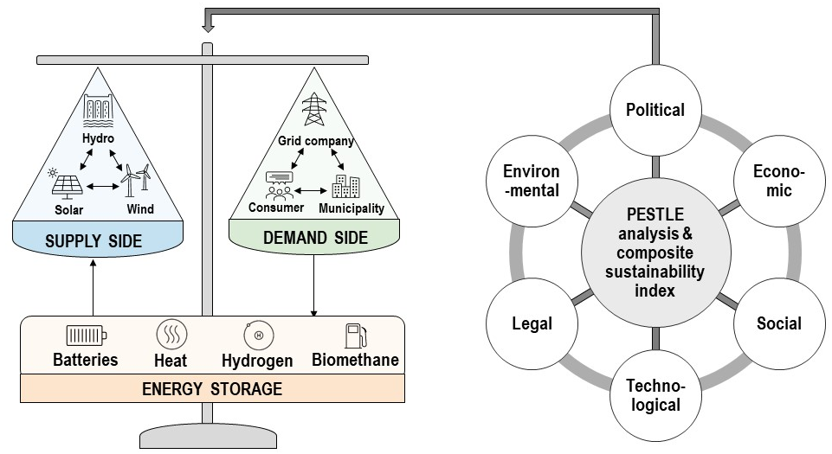
PESTLE analysis framework for renewable energy storage technologies.

Acknowledgement
People who contributed to the work should be listed in the acknowledgments, along with their contributions. You must ensure that anyone named in the acknowledgments agrees to being named.
For example, this work has been supported by the European Social Fund within the project “Development of multifunctional nanocoatings for aviation and space techniques constructive parts protection” No. 2013/0013/1DP/1.1.1.2.0/13/APIA/VIAA/027

